# **Session 6: Linear Programming for Optimisation using Excel**

A computer manufacturing company produces two models of laptop, the Air Laptop and the Pro Laptop.

The Air laptop model requires 1 motherboard, 25 electronic components and 9 hours of labour and returns a profit of $222.

The Pro laptop model requires 1 motherboard, 30 electronic components and 12 hours of labour and returns a profit of $280.

However, there are some constraints on the resources. The number of motherboard is limited to 1500/month, 10,000 labour hours and 18,000 electronic components.

**The manufacturer is interested in maximising monthly profit. What product mix achieves maximal profit?**

To answer the above question, perform the following steps:

1. Open Microsoft Excel and identify the decision variables as follows:

B3= Air laptop model

C3= Pro laptop model

1. Assign decision variable cells as follows:

Decision variable cells:

B4, C4

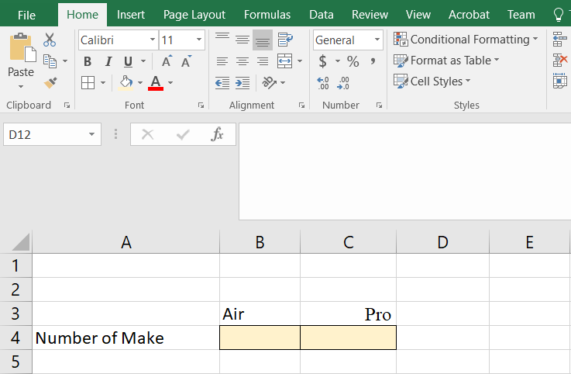

1. At this step, write the required inputs in B7, B8, B9 and C7, C8, C9 and constraints in F7, F8 and F9 as follows:

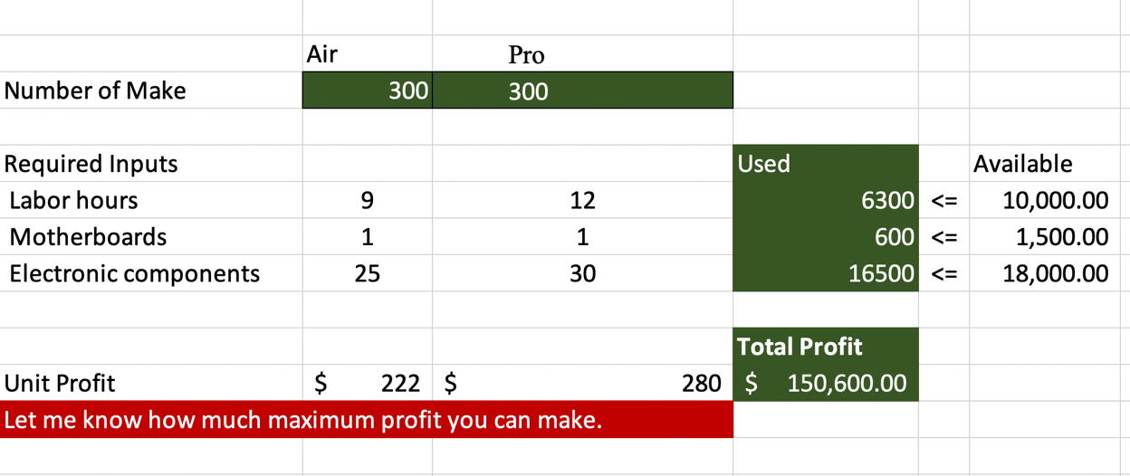

1. Write down the following formulas in the appropriate cells:

D7= $B$4*B7+$C$4*C7 (For calculating used labor hours)

D8= $B$4*B8+$C$4*C8 (For calculating used Motherboards)

D9= $B$4*B9+$C$4*C9 (For calculating used Electronic components)

D12= =B4*B12+C4*C12 (For Calculating total profit)

1. Next, from the Data tab, select Solver, and select the Total profit cell (D12) in Set Objective box and choose Max for maximising the profit.

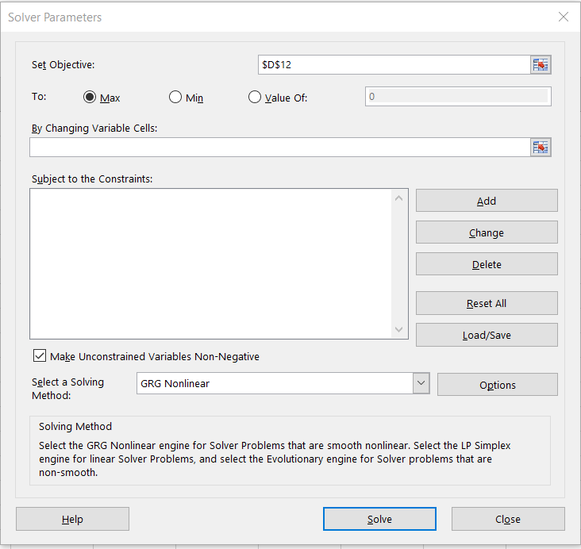

1. Then select the B4 and C4 cell for the “By Changing Variable Cells” as follows:

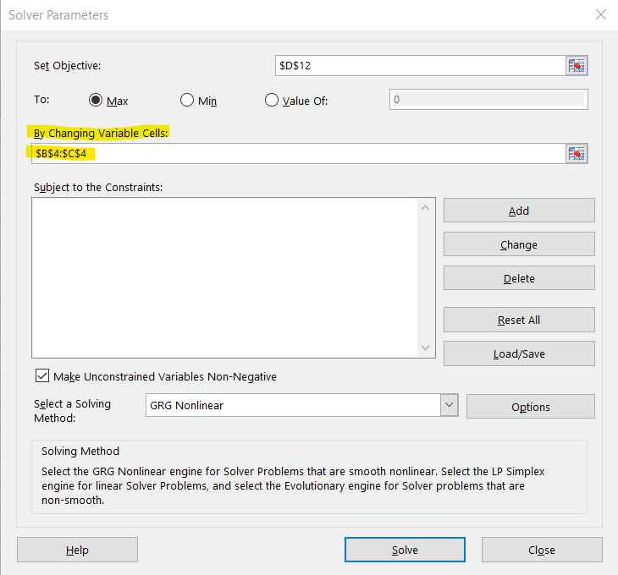

1. To add constraints, click on the Add button and enter cells D7, D8 and D9 as Cell reference and F7, F8 and F9 as Constraints and click OK.

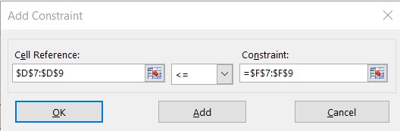

1. Before clicking on Solve, make sure that the “Make Unconstrained Variable Non-Negative” option is checked and then click on the Solve button.

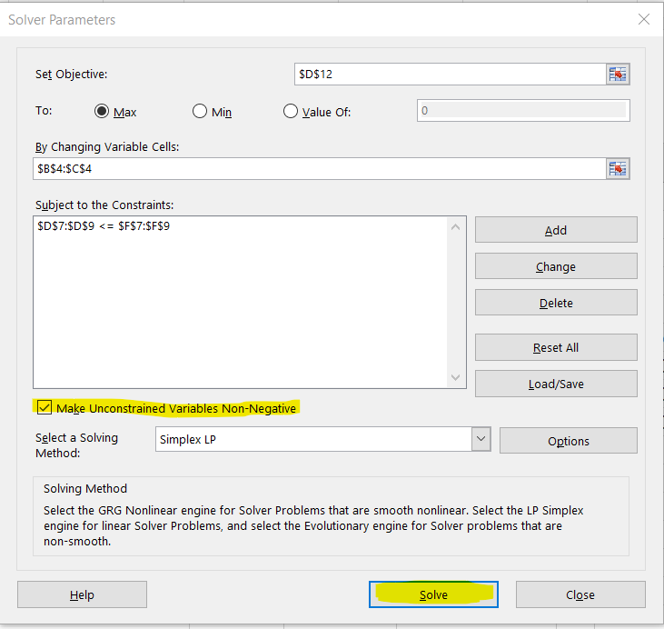

1. Now you should be able to see the maximum profit and number of models to make of the models.

# **Submission Instruction:**

1. Show the solution to your lecturer.